Clone the git@github.com:shajivmasters/Assignment.git and do a terrform init

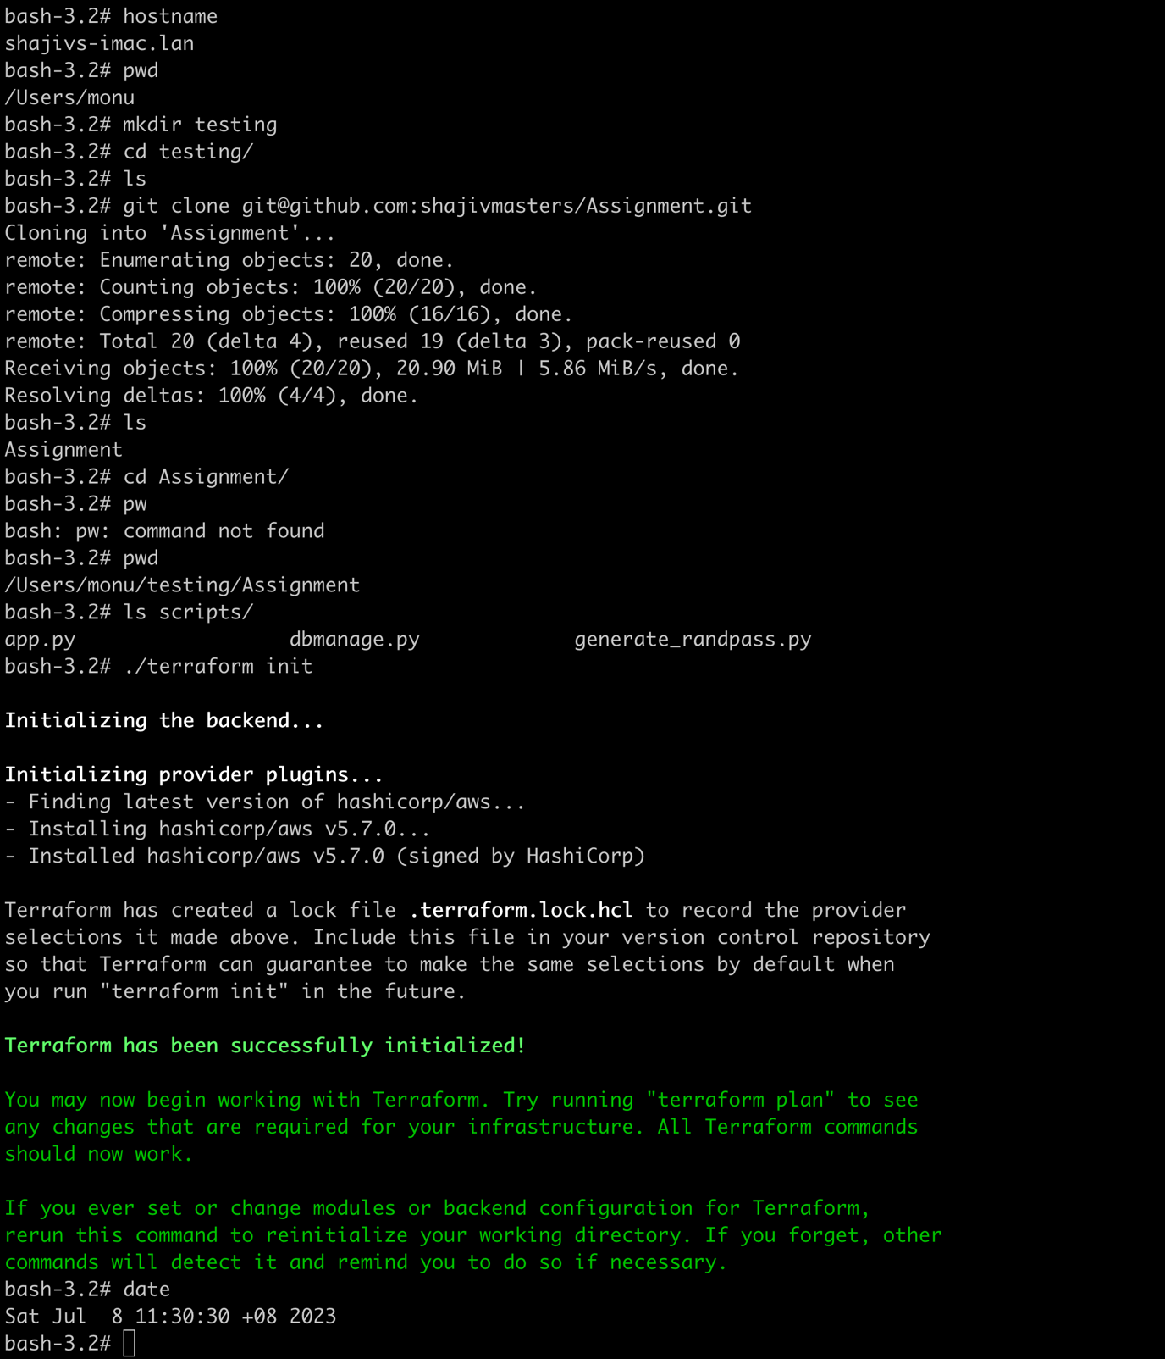

Doing a terraform plan

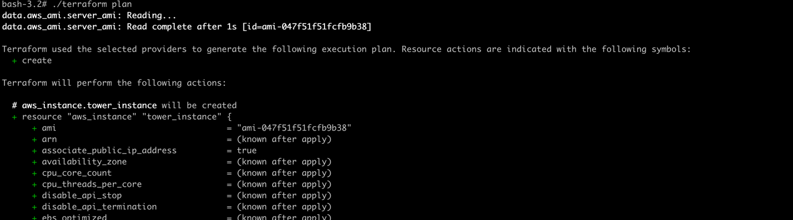

…..

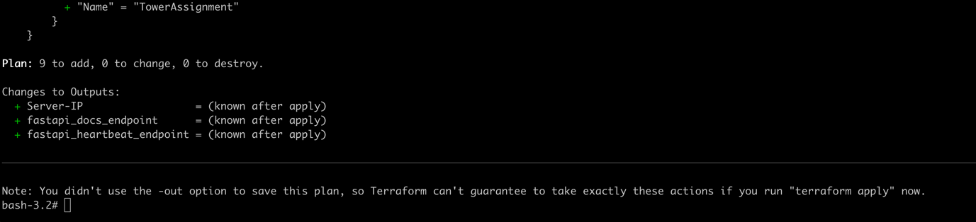

Doing a terraform apply

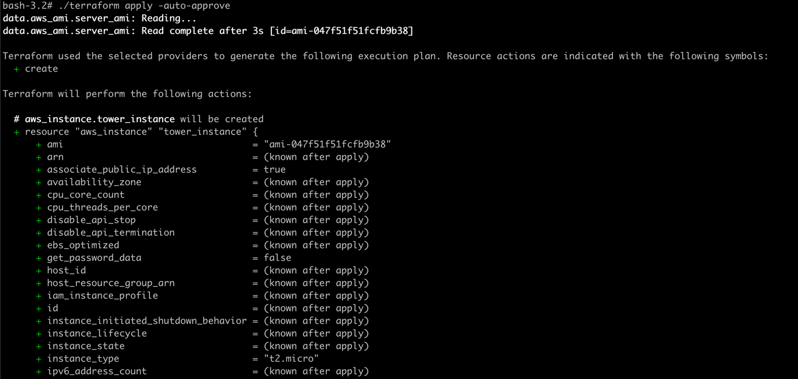

…

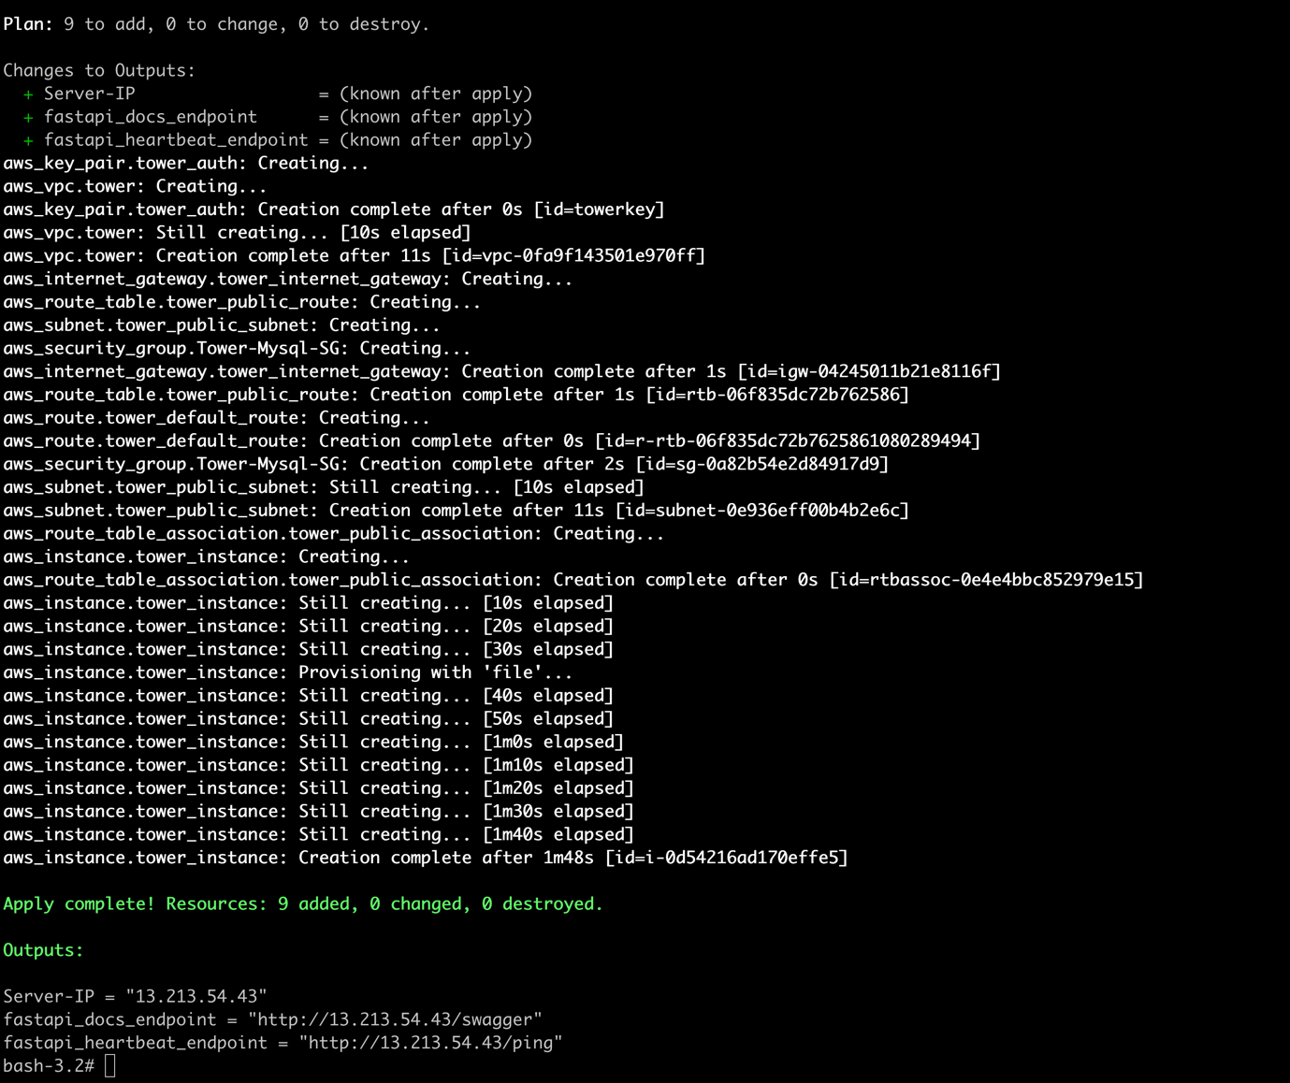

You can see that the above give the information of the EC2 instance and FasrAPI end point

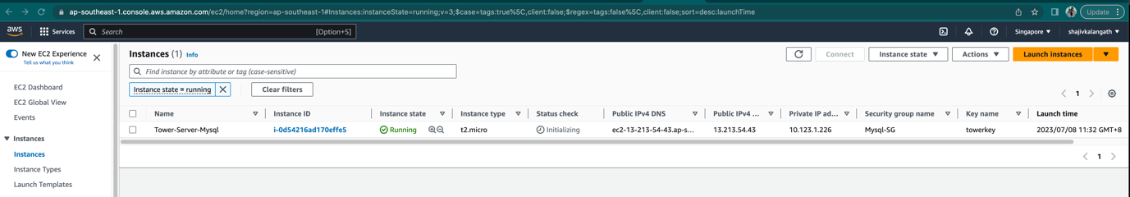

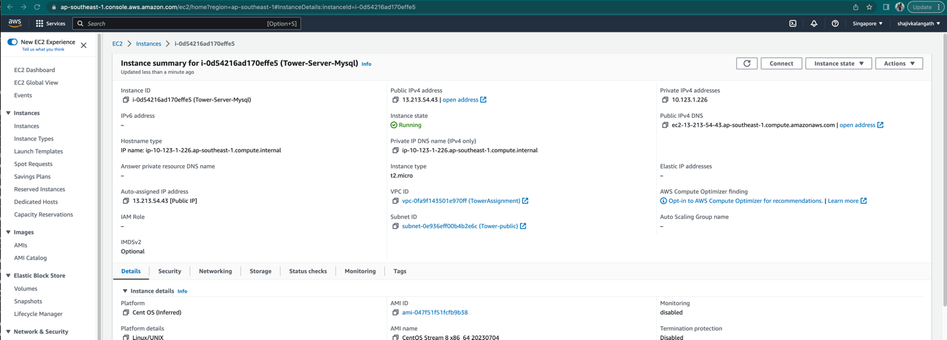

Wait for 3 to 5 minutes to login . We also test before configuring the DB and it give the error

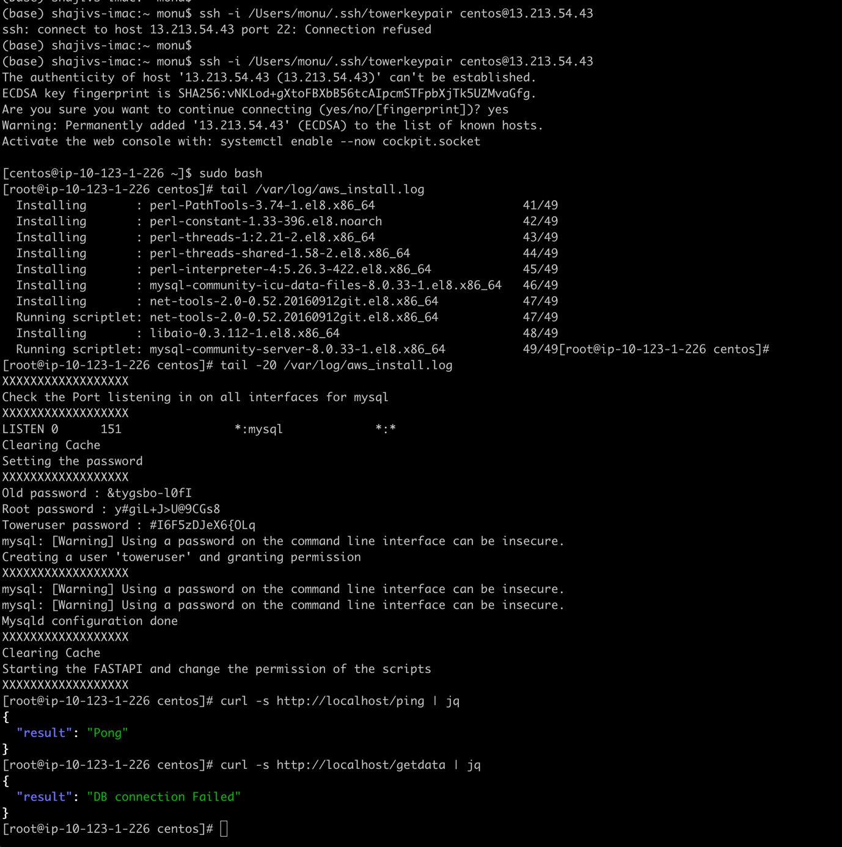

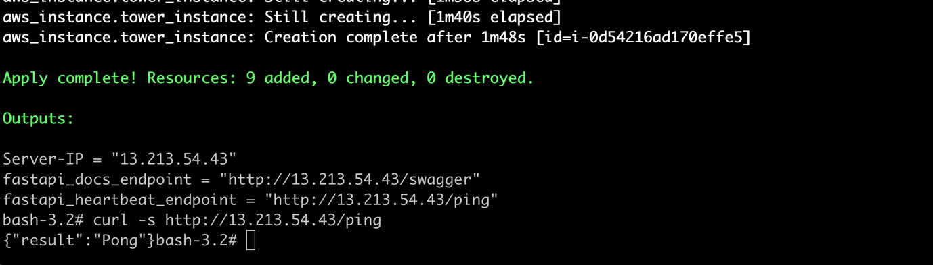

You can see that it is publically accessible

You can see the ping pong reply as a heartbeat

As you can see we are making the script to configure the DB .You cansee the interface are configured and updted hthe mysql

You can see that bootstrap the DB with the required information

You can access publicly as well



You can use throuh swagger to test as well

If you run this again and if the DB is already configured it will not mess up it just comes out also you can see the /var/log/fastapi.log for some debugging



Configuring using Swagger UI

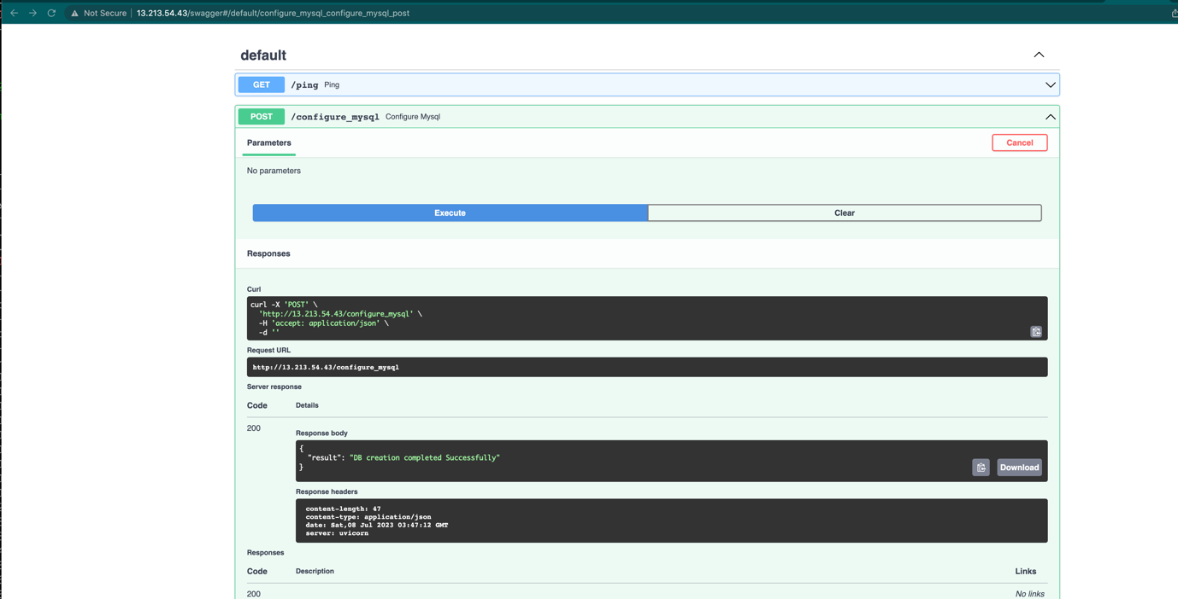

Using the /home/centos/dbmanage.py to query/update/insert and delete the data

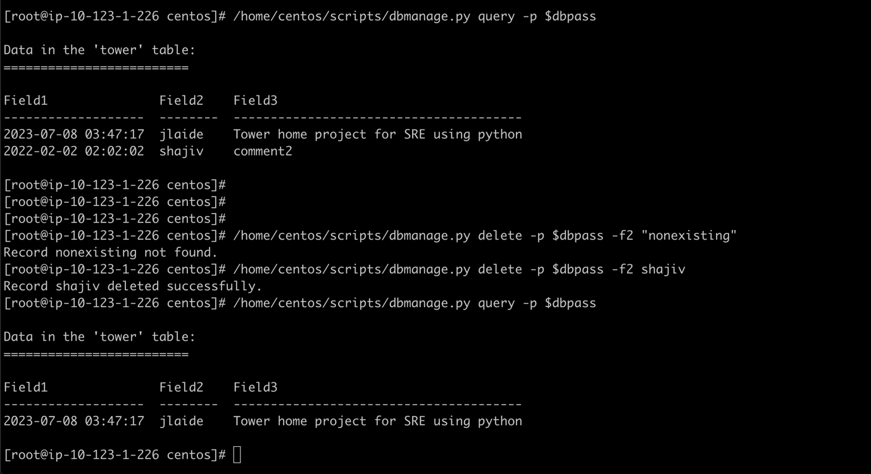

Using the Swagger UI to do the same

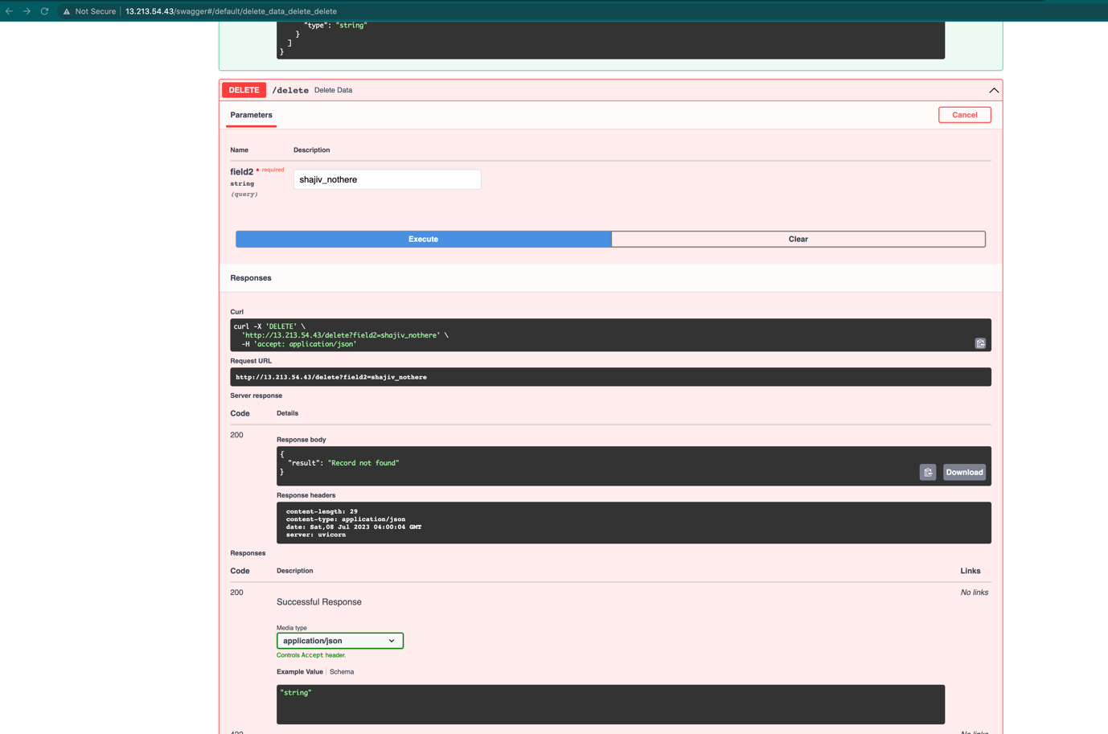

Using the CURL command to achive the same

